**Adaugarea de opcode-uri**

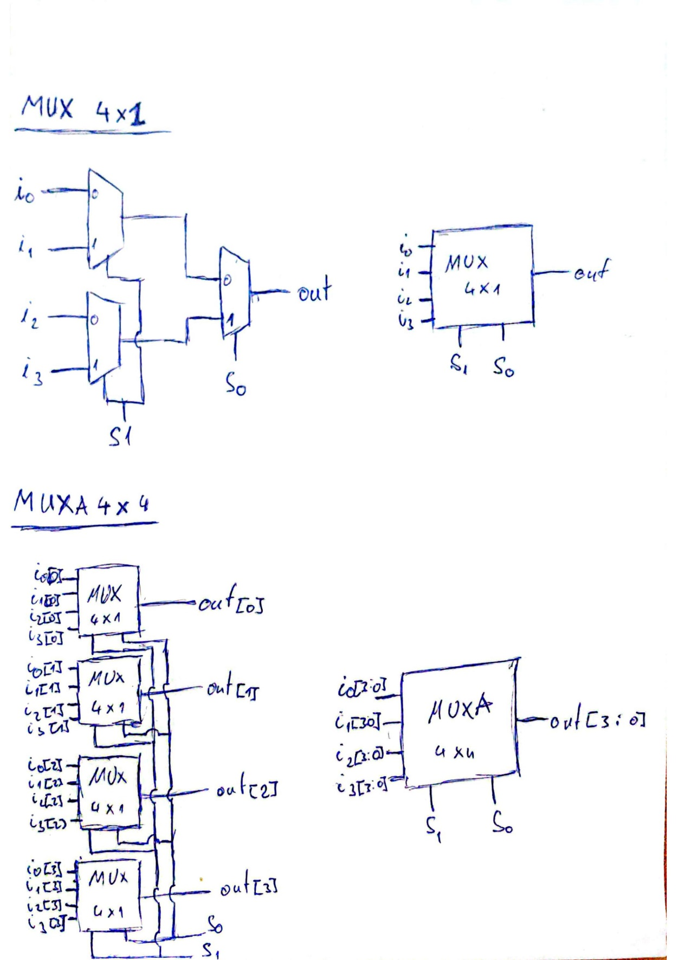

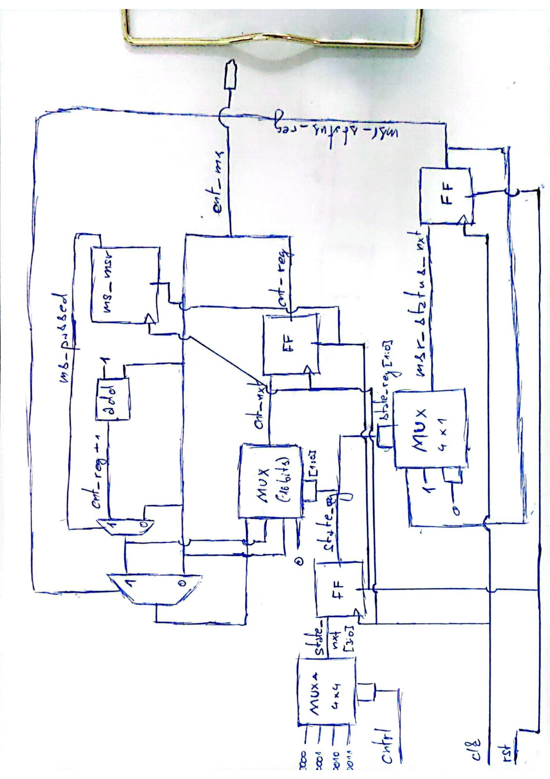

*MUXA 4x4 ar fi de fapt o implementare posibilă pentru “case”. În acest caz, primul bit este ignorat la ieșire.

**Module:**

module ms_cnt(

input clk, rst,

input [2:0] cntrl,

output [15:0] cnt_ms

);

reg [15:0] cnt_reg, cnt_nxt;

reg [2:0] state_reg, state_nxt;

reg msr_status_reg, msr_status_nxt;

wire ms_passed;

wire [15:0] cnt_clk;

localparam S0 = 3'b000;

localparam S1 = 3'b001;

localparam S2 = 3'b010;

localparam S3 = 3'b011;

ms_msr ms_msr_1(

.clk(clk),

.rst(rst),

.ms_passed(ms_passed),

.cnt_clk(cnt_clk)

);

always @(*) begin

case(state_reg)

S0: begin

if(msr_status_reg & ms_passed)

cnt_nxt = cnt_reg + 1;

else

cnt_nxt = cnt_reg;

end

S1: begin

msr_status_nxt = 1;

if(ms_passed)

cnt_nxt = cnt_reg + 1;

end

S2: begin

msr_status_nxt = 0;

cnt_nxt = cnt_reg;

end

S3: begin

msr_status_nxt = 0;

cnt_nxt = 0;

end

endcase

case(cntrl)

S0: begin

state_nxt = S0;

end

S1: begin

state_nxt = S1;

end

S2: begin

state_nxt = S2;

end

S3: begin

state_nxt = S3;

end

endcase

end

always @(negedge clk or posedge rst) begin

if(rst == 1) begin

cnt_reg <= 0;

msr_status_reg <= 0;

state_reg <= 0;

end

else begin

cnt_reg <= cnt_nxt;

msr_status_reg <= msr_status_nxt;

state_reg <= state_nxt;

end

end

assign cnt_ms = cnt_reg;

endmodule

**Testbench:**

//correct functionality for a timescale of 1ns/<precision>

module test;

initial begin

$dumpfile("dump.vcd");

$dumpvars(1, test);

end

reg clk, rst;

reg [2:0] cntrl;

wire [15:0] cnt_ms;

parameter period = 200; //200ns periods correspond to 5 MHz

parameter nr_p_s = 5000; //nr of periods in 1s

ms_cnt ms_cnt_1(

.clk(clk),

.rst(rst),

.cnt_ms(cnt_ms),

.cntrl(cntrl)

);

initial begin

rst = 1;

clk = 0;

#10 rst = 0;

cntrl = 3'b001;

end

initial begin

repeat(80000)

#(period/2) clk = ~clk;

end

initial begin

#(2 * nr_p_s * period) cntrl = 3'b010;

#(1 * nr_p_s * period) cntrl = 3'b001;

#(1 * nr_p_s * period) cntrl = 3'b000;

#(1 * nr_p_s * period) cntrl = 3'b011;

#(1 * nr_p_s * period) cntrl = 3'b001;

 end

endmodule

**Functionality:**

See waveform